User form: Vertex 70 with ATR accessory
User form for measurements with Vertex 70 FTIR spectrometer (Bruker Optik GmbH, Germany) with High Temperature Golden gate ATR Mk II (Specac, United Kingdom) single reflectance-attenuated total-reflectance (SR-ATR) accessory.

Date: 30.10.2025
User: Tianyuan Wang
Data responsible: Boris Zimmermann
Sample form: Solid (biological)
Sample name info:
In OPUS Measurement window, click on the Advanced tab.
Use Snipping Tool to capture a screenshot of the Measurement window: 
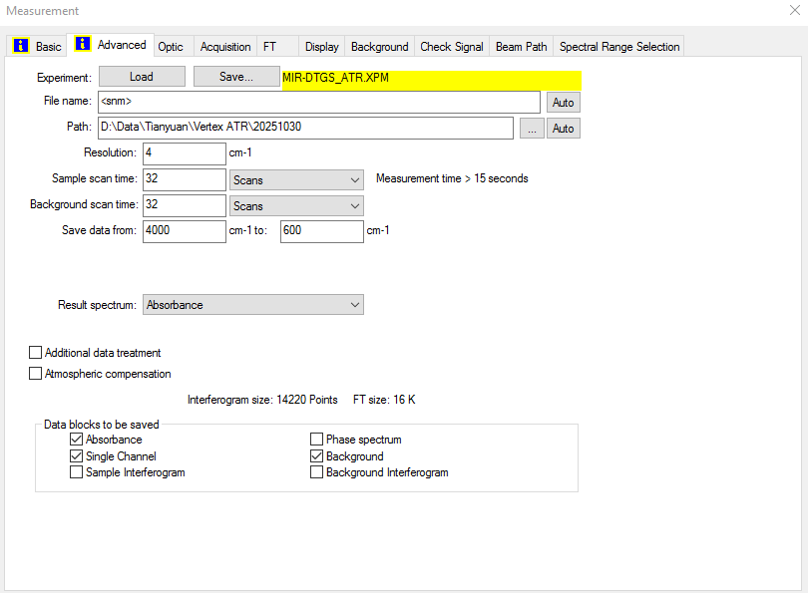
Year_GH_Pmu_cul_Frame_UV/CON_ID_#_FTIR#
(example: 2024_GH_Pmu_cul_A_UV_001_#1_01)
Year – The year the pollen was sampled (2024)
GH – Greenhouse sample
Pmu – The species: Pinus mugo
cul – Sampled from cultivars
Frame – Frame ID (A-F)
UV/CON – Treatment, either UV or control
ID – Unique ID number for each cultivar
# - sample replicate number (only if there are sample replicates)
FTIR# - FTIR replicate number

